FRANCIS XAVIER ENGINEERING COLLEGE – TIRUNELVELI
DEPARTMENT OF COMPUTER SCIENCE AND ENGINEERING
BATCH : 2015 – 2017 II M.E - CSE (NW)
- . |  | NAME :  DOB :  ADDRESS :  EMAIL ID :  CONTACT NUMBER : | ESWARI A  21.06.1993  D/O. V. ANAVARATHAM,  NO. 6, RAMARSWAMY KOVIL STREET (BACKSIDE HOUSE),  FACING MUTHARAMMAN KOVIL STREET,  PALAYAMKOTTAI,  TIRUNELVELI-627002  eswari793@gmail.com  9629760477
 |  | NAME :  DOB :  ADDRESS :  EMAIL ID :  CONTACT NUMBER : | JENO MACTALIN PEARS J  25-05-1994  D/O.P.JEYA KUMAR  330 2/4 MAIN ROAD,  T.KALLIKULAM-627113  piyapears1994@gmail.com  8870016259
 |  | NAME :  DOB :  ADDRESS :  EMAIL ID :  CONTACT NUMBER : | KALYANI SUNDARI A  25.05.1994  D/O.MR.P.ARUMUGAM  2/75A,VANNIYAR STREET,  POTTALPUDHUR,  TIRUNELVELI-627423  kalyaniarumugam25@gmail.com  7868832359
 |  | NAME :  DOB :  ADDRESS :  EMAIL ID :  CONTACT NUMBER : | KARTHIKA A  28.12.1993  D/O P.ARUNACHALAMURUGAN  NO.6, B BLOCK,  SRIPURAM POLICE COLONY,  TIRUNELVELI-627001  Karthika28121993@yahoo.com  9486401449
 |  | NAME :  DOB :  ADDRESS :  EMAIL ID :  CONTACT NUMBER : | D.NISHAN NITHYA  28.06.1993  D/O.M.DHAKSHANA MURTHY,  ¾,SH, MANSION,  THIRUKOVAIYAR STREET,  VANNARPETTAI,  TIRUNELVELI-627003  nithymurthy20@gmail.com  9629249969
 | 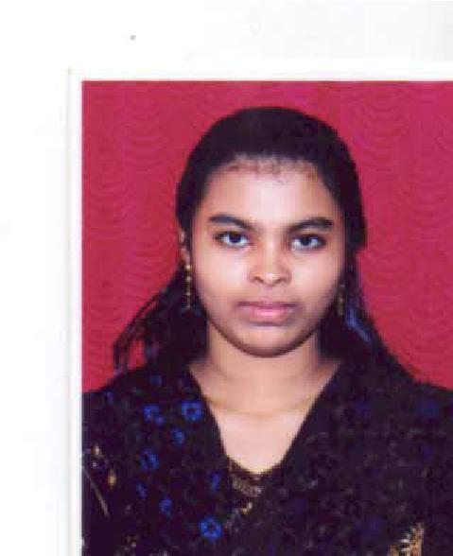 | NAME :  DOB :  ADDRESS :  EMAIL ID :  CONTACT NUMBER : | E.PRAISY  04-01-1994  D/O. D.EDWARD,  17 TH K.M.A NAGAR,  PERUMALPURAM,  TIRUNELVELI-627007  praisyriya@gmail.com  9994602991
 |  | NAME :  DOB :  ADDRESS :  EMAIL ID :  CONTACT NUMBER : | PRIYANGA.M  29/03/1992  D/O. M.E.S.MUTHU,  38/1,EAST STREET,  KUMBIKULAM(NORTH),  SEELATHIKULAM(POST),  RADHAPURAM TALK,  TIRUNELVELI DIST,PIN: 627112  Priya29392m@gmail.com  9944997403
 |  | NAME :  DOB :  ADDRESS :  EMAIL ID :  CONTACT NUMBER : | R.RASI RAJ  25/05/1994  D/O. MR. RAJENDRAN,  KUMARU BHAVAN,  PAZHAYA UCHAKKADA ,  KAKKAVILA P.O  TVM  PIN- 695506  rasirari@gmail.com  9688263590
 |  | NAME :  DOB :  ADDRESS :  EMAIL ID :  CONTACT NUMBER : | RENGA VENI N  16-02-1994  D/O. MR .L. NAMBIRAJAN  6/1, POST OFFICE STREET, PALAYAMKOTTAI.  TIRUNELVELI-627011  rengaveninambi@gmail.com  9442407136
 |  | NAME :  DOB :  ADDRESS :  EMAIL ID :  CONTACT NUMBER : | SANKARI S  19.09.1988  D/O. A.SAMUDRAPANDI  1B,NO 8,5TH STREET,  RAJENDRA NAGAR,  PALAYAMKOTTAI.  TIRUNELVELI-627002  sankari.pandi@gmail.com  9789892322
 |  | NAME :  DOB :  ADDRESS :  EMAIL ID :  CONTACT NUMBER : | SINDHUKAVI K  22.06.1993  D/O. MR. KAVERI.V  L.335 POLICE COLONY  SHANTHINAGAR  PALAYAMKOTTAI  TIRUNELVELI-627002  sindhukavi22@gmail.com  9994982607

